Daniel Llumiquinga - WDD 131

Plan Document for the project

Site Name:

Manta, Ecuador's best and affordable Hotels!

Branding: Dream’s Ecuador

This name represents the objective of this site and why the people need to come and reserve hotels with us.

Site Purpose:

This site provides hotels options in the beaches of Ecuador, specially in Manta the best and most tourism city to visit, along with the opportunity to reserve them.

Scenarios:

   <!-- what is the best site to find good and affordable hotels? -->

   <!-- Can I reserve the hotels in this website or do I need to other sites to do it? -->

Color Schema:

Heading: Aqua color

Body: Green color

Letters: white

Footer: Aqua color

Sections and divisions: blue color

Typography:

Font for header, footer and h attributes: Roboto

Font for div, and p elements: Winky Sans

Hotel Wireframe:

Desktop View Mobile view

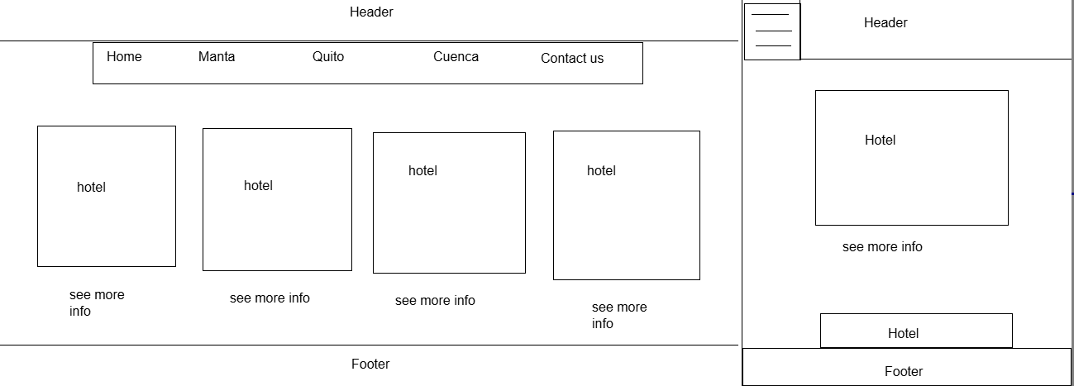

The Page will have the option to reserve the hotel’s room for each hotel, so it will have a form as well.